Airline pricing strategies of airline routes

This file is designed to show the pricing strategies of airlines flying directly out of Dublin or the closest direct flight to Dublin to the destinations shown below. All of the flights searched were one adult passenger with the view to creating prices for children and infants based on a percentage of the full adult price.

Destinations:

1. London - Heathrow
2. Amsterdam – Schiphol
3. New York – JFK
4. San Francisco – International Airport
5. Dubai – international Airport

All flights are based one person on the 20/11/2017 and return on 27/11/2017.

1. Aer Lingus - Dublin to Heathrow

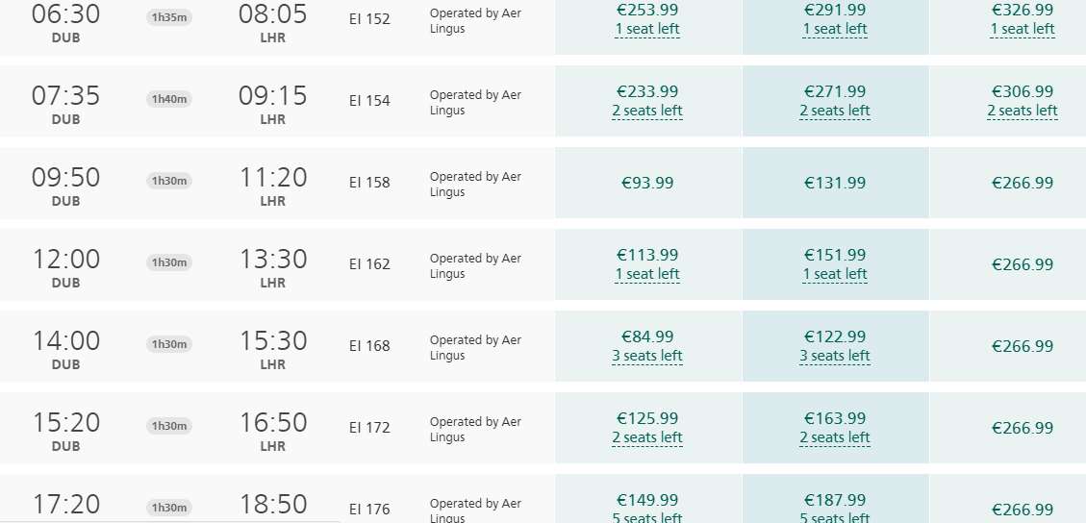

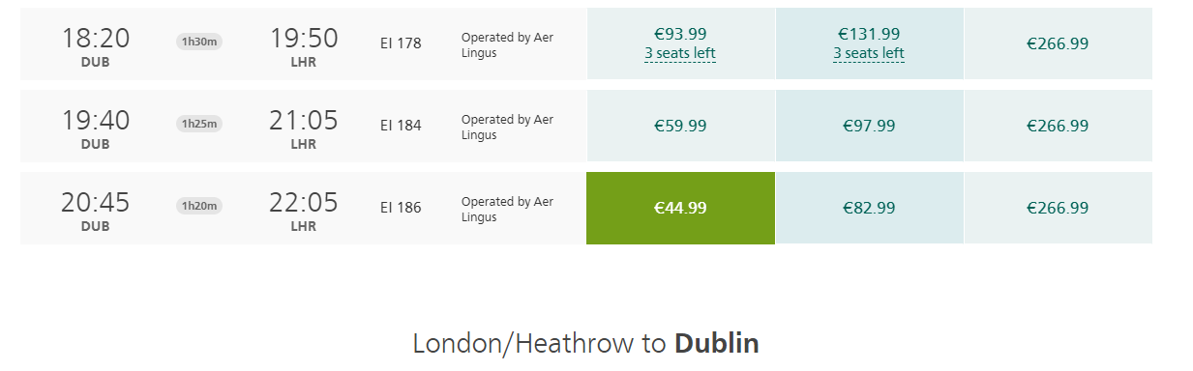

Aer Lingus fly over and back to London Heathrow 20 times a day and above shows the pricing in different flights throughout the day.

1. Dublin – Amsterdam

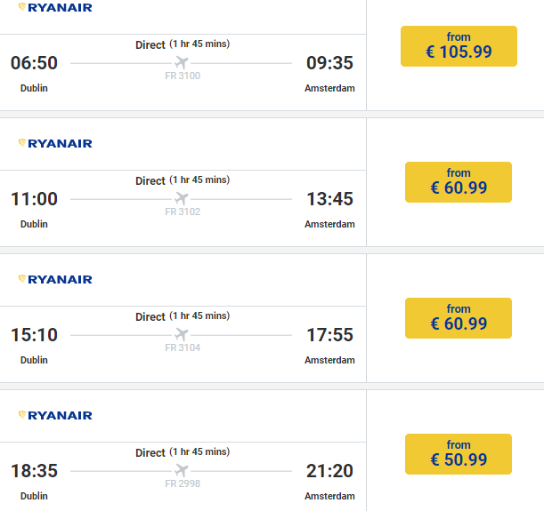

Ryanair are the cheapest air line that fly from Dublin to Amsterdam, flight prices decrease as the later the day gets.

1. Dublin – New York

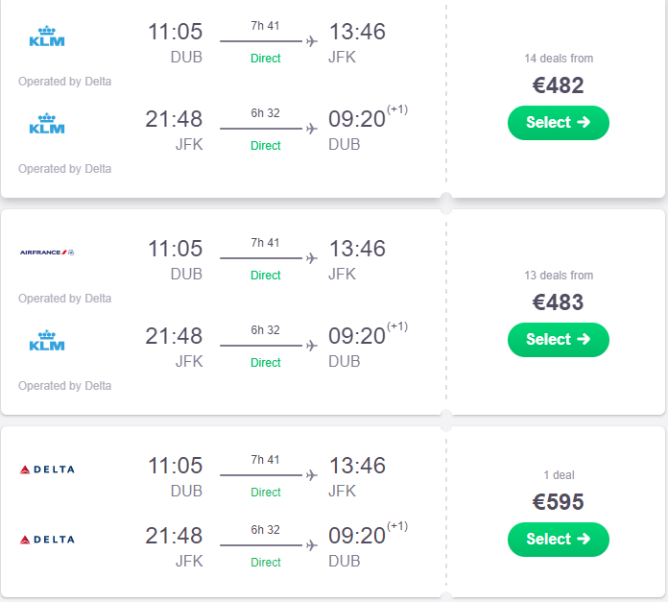



Sky scanner was used to determine the cheapest direct route.

1. Dublin – San Francisco



Aer Lingus only operates one flight per day to San Fran from Dublin.

1. Heathrow – Dubai



There are no direct flights from Dublin to Dubai so the nearest airport with a direct flight was London Heathrow.